create table cars_stock

(

car_stock_id NUMBER (18) PRIMARY KEY,

model number (18),

year varchar(4),

trim varchar (10)

)

Query1.

create table model_name

(

model_name_id number (18) primary key,

model_number number(6) REFERENCES cars_stock(car_stock_id),

tyers varchar (50)

)

create table kilometers

(

kilometers_id varchar (10) primary key,

kms_runs number (9) REFERENCES model_name(model_name_id),

KMS varchar (100)

)

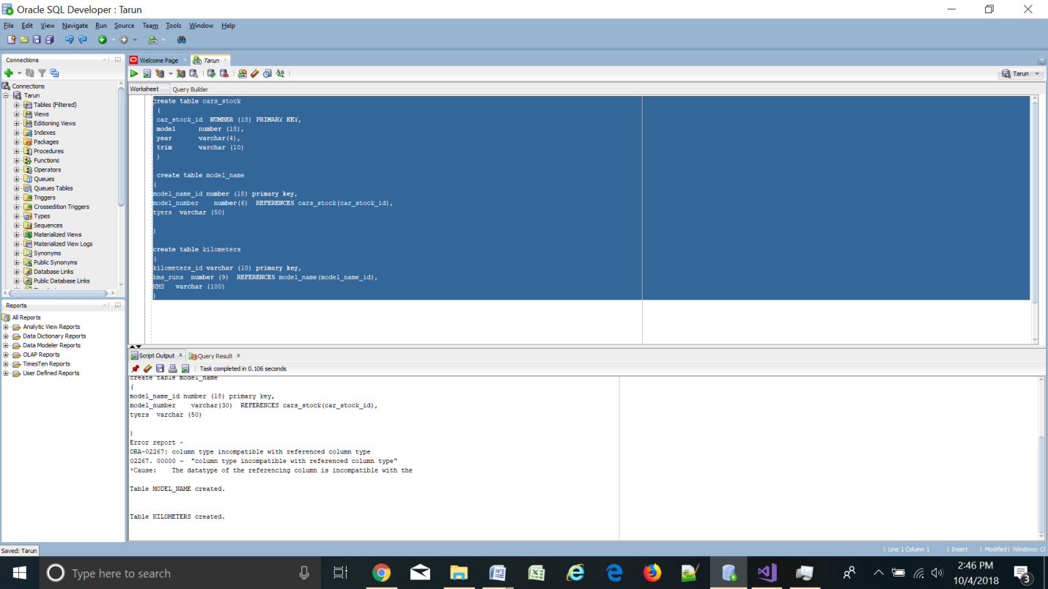

Query 2.

insert into cars_stock

values (11001, 1231, 2016, 'crv');

insert into model_name

values (121001,11001,'in-running-conditon');

insert into kilometers

values (100011,121001,232425);

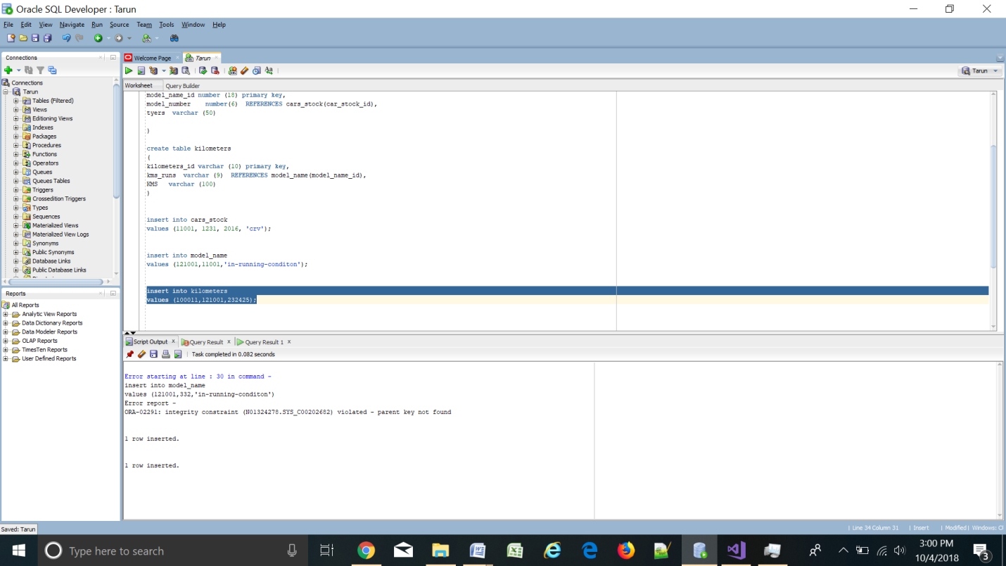

Query 3.

select *

from cars_stock

join model_name

on cars_stock.car_stock_id = model_name.model_number

join kilometers

on model_name.model_number=model_name.model_name_id

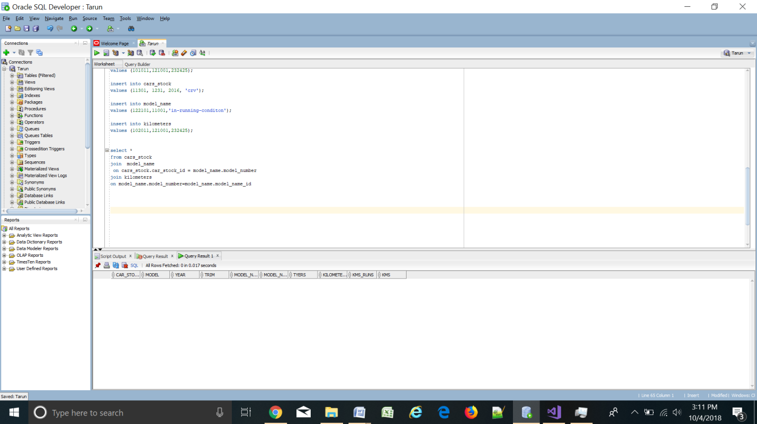

Query 4.

ALTER table model_name

ADD features varchar(25);

Query 5.

alter table cars_stock

rename to stock

